

<Name-of-Software-Application>

# **CS 230 Project Software Design Template**

Version 1.0

## Table of Contents

**CS 230 Project Software Design Template**1

**Table of Contents**2

**Document Revision History**2

**Executive Summary**3

**Design Constraints**3

**System Architecture View**3

**Domain Model**3

**Evaluation**3

**Recommendations**5

## Document Revision History

| Version | Date | Author | Comments |
| --- | --- | --- | --- |
| 1.0 | 06-10-2021 | Bijal Chauhan | Working game, team and player classes. Added new class named Entity class. |

**Instructions**

Fill in all bracketed information on page one (the cover page), in the Document Revision History table, and below each header. Under each header, remove the bracketed prompt and write your own paragraph response covering the indicated information.

## Executive Summary

The world has experiencing challenges in developing a lose it or draw it games that serve in a numerous platform. One of the common challenges is that players were drawing images on an easel to help team members guess the puzzle. This led to the delay and less enjoyment of the game. Another problem is that a sudden rise in demand has been experienced in the creative technology solutions where individuals request new games that serve different environments. Due to sudden rise in demand for mobile applications and web-based games, Creative Technology Solutions (CTS) has recently taken on a new client, The Gaming Room. Currently the new game is only available in an Android app only. The application will render images from large library of stock drawings as clues rather than a player drawing images on frame.

## Design Constraints

Design phase is one of the important phases when developing any application. When developing web-based software, there are few design constraints that we need to take into consideration. For example, constraints are ESS diagram, UML diagram, and class diagrams. All these examples are non-functional elements that help the software developer to have a visual awareness of the required software. They provide the developer with required programming tools and technology from the customers. These constraints further imply the main actors, artifacts, classes, and roles that letter allows for better understanding and documenting of the developed software.

## System Architecture View

Please note: There is nothing required here for these projects, but this section serves as a reminder that describing the system and subsystem architecture present in the application, including physical components or tiers, may be required for other projects. A logical topology of the communication and storage aspects is also necessary to understand the overall architecture and should be provided.

## Domain Model

The UML diagram below has seven classes: Entity, Game, GameService, Player, ProgramDriver, SingletonTester, and Team. Entity class is a parent class where it relates to the other four child classes. Game, Gameservice, Player, and Team relates to each other in an association relationship where each entity depends on the other one. The SingletonTester class inherits from ProgramDriver class that is the main class. The most object-oriented programming principle applied in this UML diagram is inheritance as mentioned earlier. It has enabled the SingletonTester class to perform activities and responsibilities inherited from the main class.

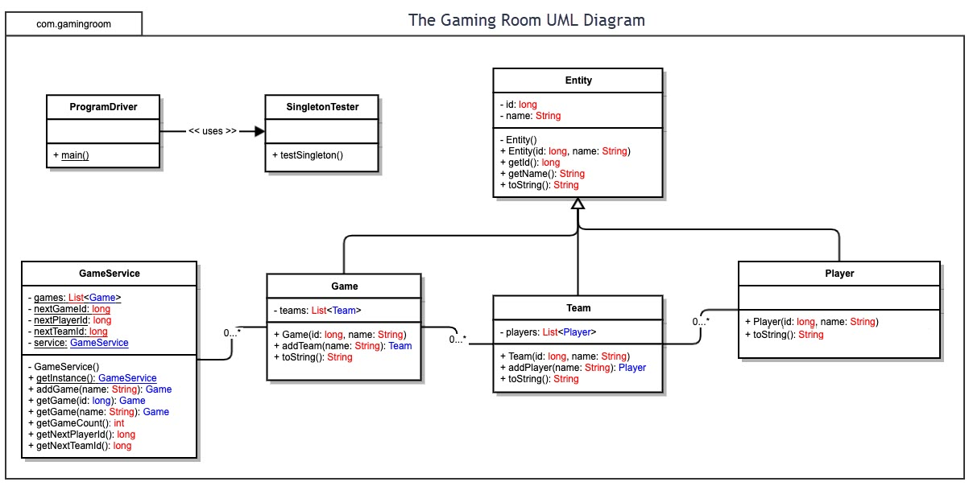

## Evaluation

Using your experience to evaluate the characteristics, advantages, and weaknesses of each operating platform (Linux, Mac, and Windows) as well as mobile devices, consider the requirements outlined below and articulate your findings for each. As you complete the table, keep in mind your client’s requirements and look at the situation holistically, as it all has to work together.

In each cell, remove the bracketed prompt and write your own paragraph response covering the indicated information.

| **Development Requirements** | **Mac** | **Linux** | **Windows** | **Mobile Devices** |
| --- | --- | --- | --- | --- |
| **Server Side** | It is popular in web hosting. The advantages are it is upgradeable and has various options for different web hosting requirements. The only disadvantage is it is less preferred for web hosting services. | It is characterized as most secure and preferred. The advantage is security flaws are caught before they become an issue. The disadvantage is it is more difficult to find application to support the web hosting required needs. | It is dominant to the other close platforms. The advantages are high resource requirements, less loading time, and high comfort ability. The disadvantages are easy virus sensitivity and poor technical support. | It is characterized as more popular and high portability. Its advantages are it has wider reach better compatibility, and cost effective. The disadvantages are it is highly selective to various smart mobile devices and poor security. |
| **Client Side** | High expertise required to develop software for clients who pertain to Mac. It is expensive as the clients are charged monthly. Time consuming in accessing the software. | Requires high expertise as only few applications are available. It requires less loading period. It is expensive and not so popular. | It requires a high expertise as it has high resource requirements. It also requires less loading period. It is also expensive because many resources are required. | It is cost-effective. It takes minimal time to load the page. It is very common, so it has high technical support for the clients. |
| **Development Tools** | PHP programming language JavaScript. | PHP programming language. | Java programming, HTML/CSS NetBeans. | Android studio, Android programming. |

## Recommendations

Analyze the characteristics of and techniques specific to various systems architectures and make a recommendation to The Gaming Room. Specifically, address the following:

1. **Operating Platform**: Windows Operating Platform is the recommend environment as it is common platform in developing web-Based software. It is highly secured with less loading time and is relatively cheap. It is compatible and portable, and therefore suitable for the development of the Lose It or Draw It game.
2. **Operating Systems Architectures**: The windows operating platform has two main components that are the user model and kernel model. It is preemptive and reentrant operating systems designed to work with either symmetric multi-processor or uniprocessor. The kernel mode has unrestricted access to the system memory and external devices while programs and subsystems in user mode are limited in terms of what system resources can be accessed.
3. **Storage Management**: Database management system is one of the best storage systems that will work effectively with windows. Due to its high compatibility, this storage system is suitable for the windows. It is easy to use and runs in multiple operating platforms. It is also highly adaptive.
4. **Memory Management**: To accommodate the heavy use from the Draw It or Lose It software, Windows applies memory compression technique. This will increase the responsiveness of the operating system. Another technique is the page file system where windows will start removing pages of memory out of RAM and store them temporarily on the hard disk when the amount of memory for the Draw It or Lose It software exceeds the Ram Available.
5. **Distributed Systems and Networks**: Using LAN as the networking technology, the distributed system will use hubs to connect multiple computers such that when one computer crashes, the game still operates. The hubs will also serve as a repeater to amplify the signals that deteriorates when travelling for long distance. Having LAN as our reliable network and Hub as the connectivity hardware, it will help the system to have a small outage overall.
6. **Security**: To ensure the client’s details are secured, protection measure will be put into consideration. The encryption of the client’s data will be the basis of security for this application. Due to the high security capabilities for windows operating platform, the user protection against intruders will be higher.